Introduction to Dr. Racket for Scheme.

Dr. Racket is a graphical IDE which can be used to program in the Racket Programming language, as well as the Scheme language.

To Download Dr. Racket, go here: <https://download.racket-lang.org/>

This is what the program should look like after installing (This guide was creating using MacOS but should be similar for other operating systems):

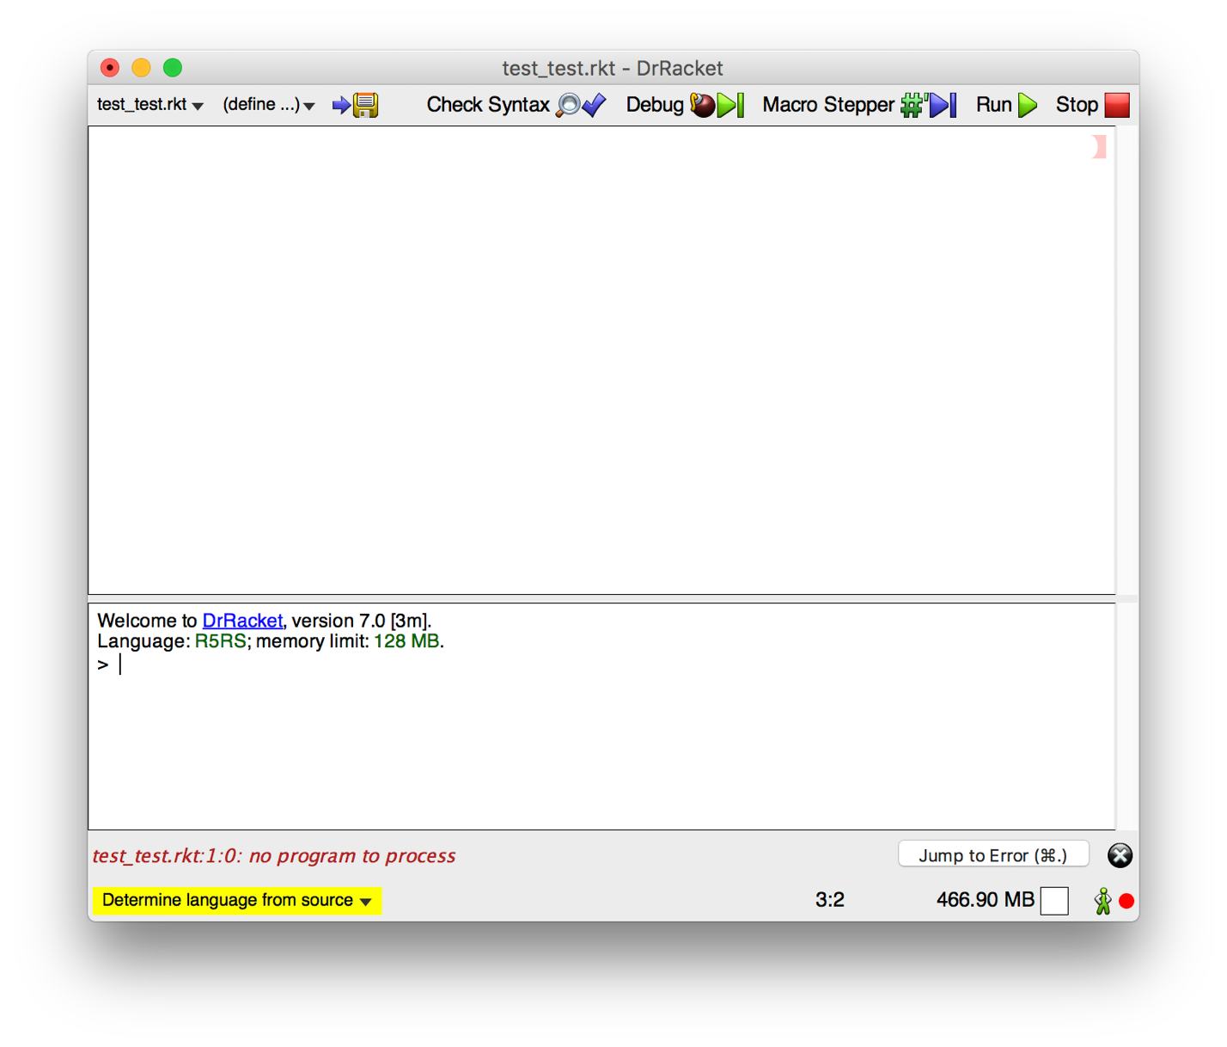

In order to run Scheme programs, Dr. Racket will need to be set to run the R5RS language:

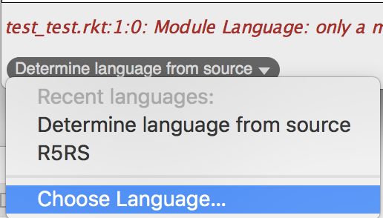

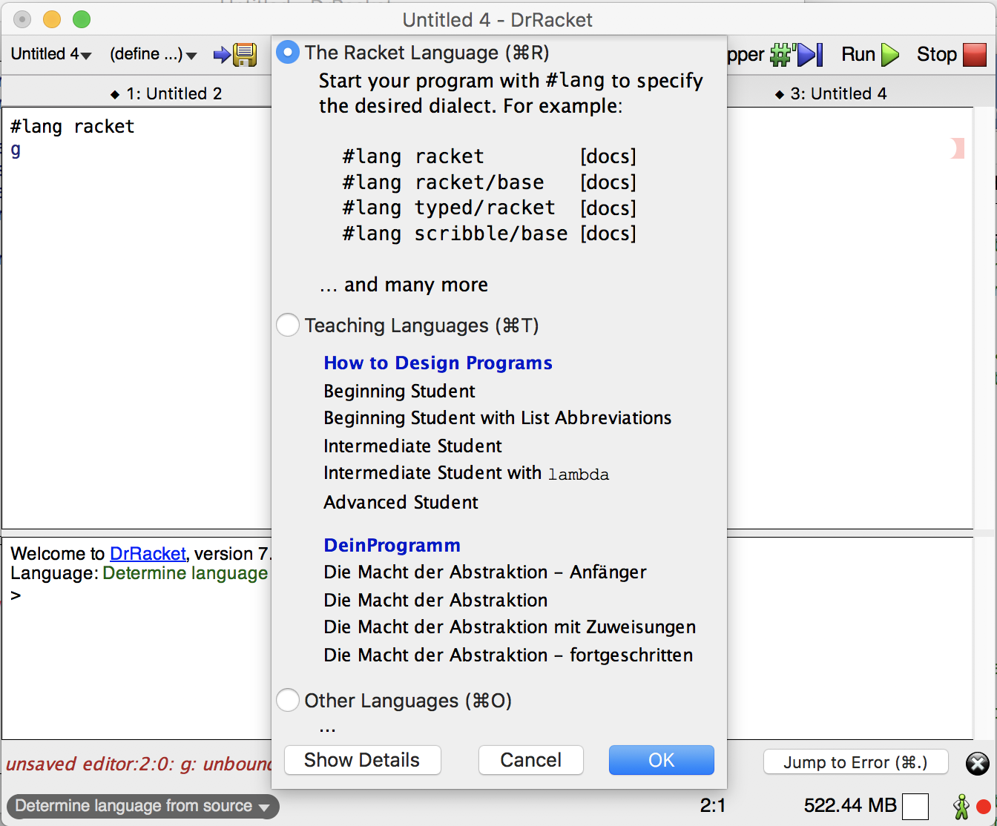

Click the racket language. you can click the Run button at the top of the screen to run your Scheme programs, and see the output below. Make sure to have #lang racket at the top of the program. This is so that built in functions should work out of the box, for instance the filter function.

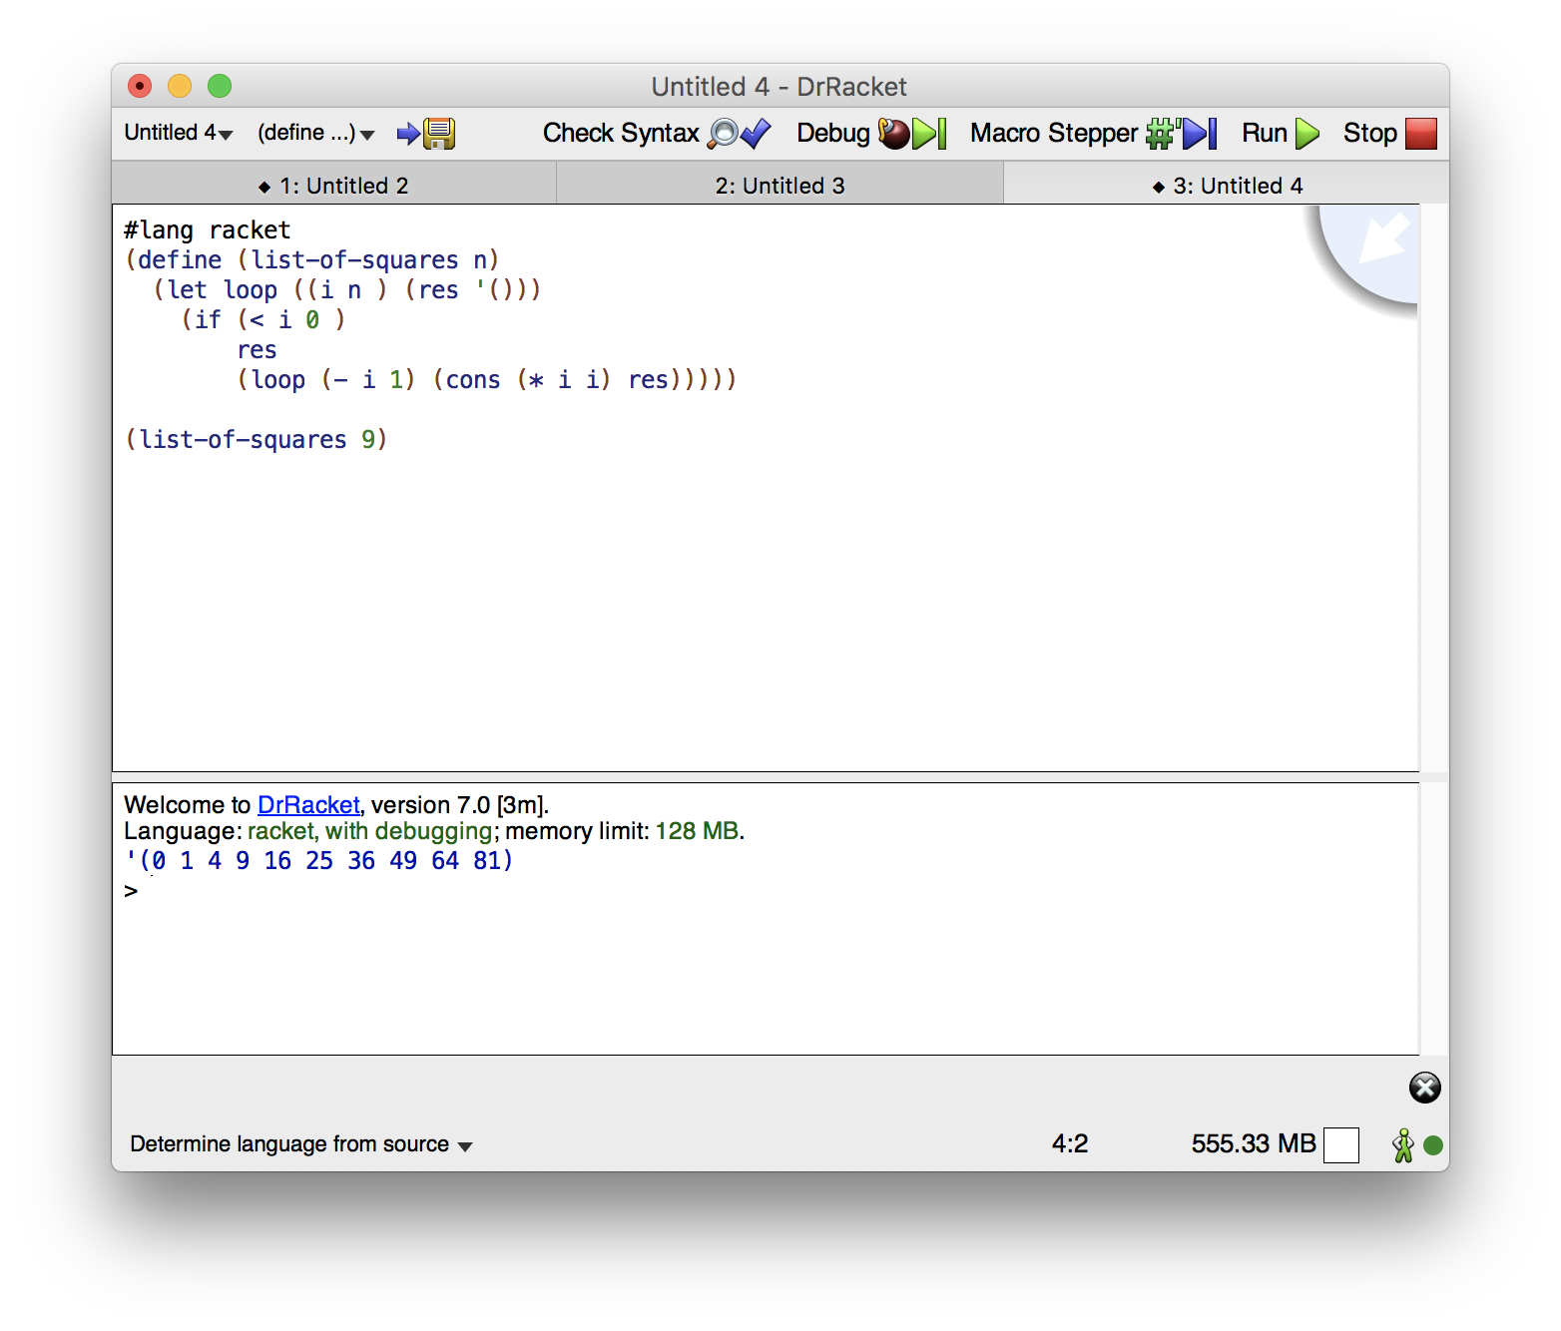

To debug a program, you can click the Debug button, and set a break point by right clicking where you would like the program to stop execution.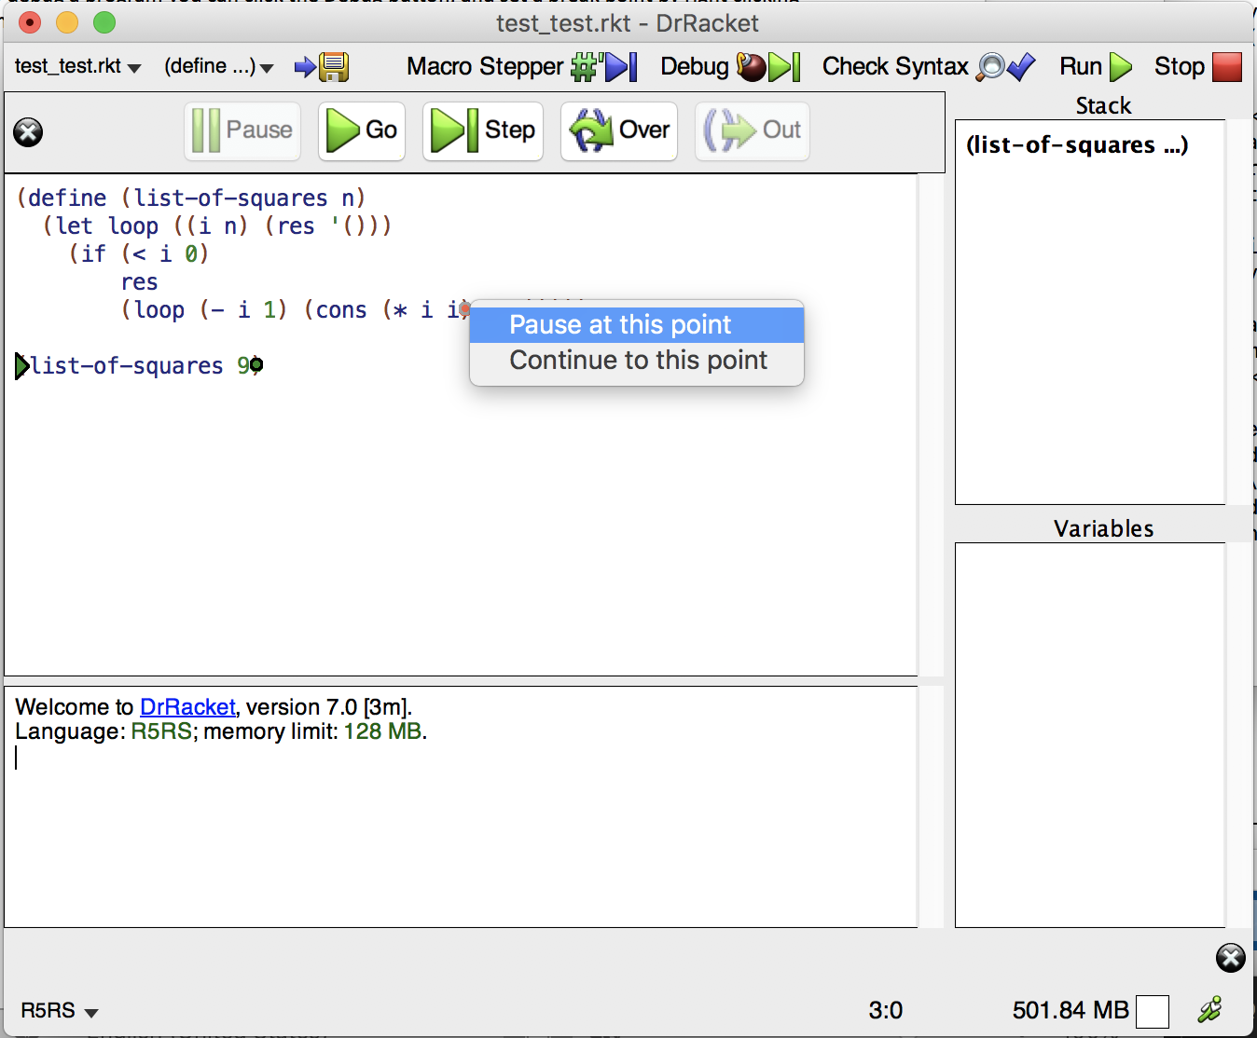

Click either Go, to run until your breakpoint, or you can click the Step button to step through your program line by line, and see the stack and variables change as it’s running.

For a more in depth look on everything in Dr. Racket, the official resource can be found here: <https://docs.racket-lang.org/drracket/index.html>